**Database Design Analysis:**

**1. Understanding of Sample Data File:**

The sample data file represents a grocery store inventory and transaction system. Each entry records details of purchases or sales, encompassing information such as item type, description, quantity, cost, vendor details, sale price, sale date, and customer ID.

**2. Anomalies and Dangers in the Original Sample Dataset:**

The first noticeable thing about the original sample dataset is how disorganized and unclear it was, making it a minefield of database anomalies, namely Insertion, Deletion, and Update Anomalies. The following points clarify and summarize where each of these anomalies manifested in the original design:

a. **Redundancy of Information:**

* The dataset exhibited redundancy with repeated information like vendor details for each purchase, leading to inefficiency and increased storage requirements.

b. **Disorganized Structure:**

* The dataset lacked a structured format, making it challenging to retrieve, filter, and analyze information effectively.

c. **Combining Purchases and Sales:**

* Storing purchases and sales in the same table hindered the ability to accurately determine the final quantity on hand, impacting inventory management.

d. **Inconsistent Unit Representation:**

* Inconsistencies in representing units (e.g., "ounce" and "oz") introduced difficulties in data filtering and analysis.

e. **Unclear Vendor Address:**

* Lack of clarity in vendor addresses posed challenges for filtering, managing, and analyzing vendor-related information.

f. **Column Placement:**

* Misplacement of columns, such as item type and location at the end, added complexity to data interpretation and query formulation.

**3. Database Design Solutions:**

a. **Bridge Table Creation:**

* Introduced a bridge table to separate purchases, enhancing data normalization and minimizing redundancy.

b. **Optimized Quantity On Hand Calculation:**

* Implemented optimized calculations for quantity on hand by factoring in both purchases and sales, ensuring accurate inventory management.

c. **Structured Schema:**

* Designed a structured schema with meaningful table and field names, enhancing data organization and readability.

**EERD of the Green Spot grocery store database:**

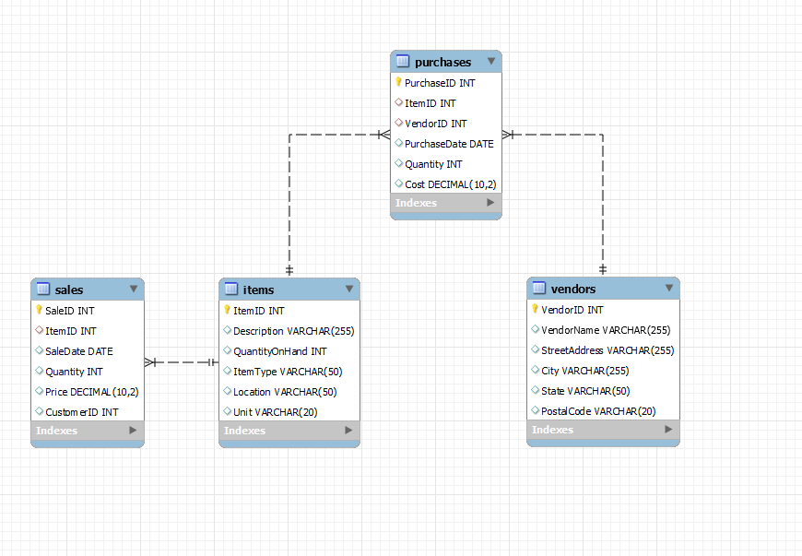

**Tables**

Items:

Vendors:

Purchases:

Sales

**Field Types**

Items:

Vendors:

Purchases:

Sales

**Select and Join Queries:**

1. Displaying purchase details with item information:  
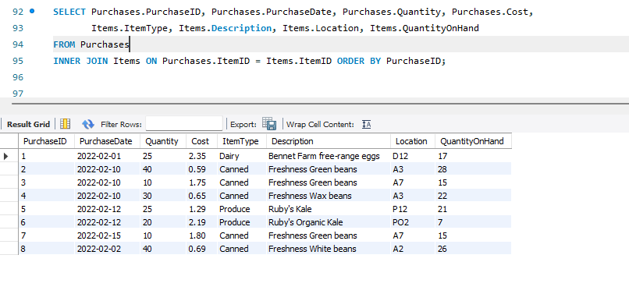

3. Listing all items with their associated purchases and sales with their respective details:

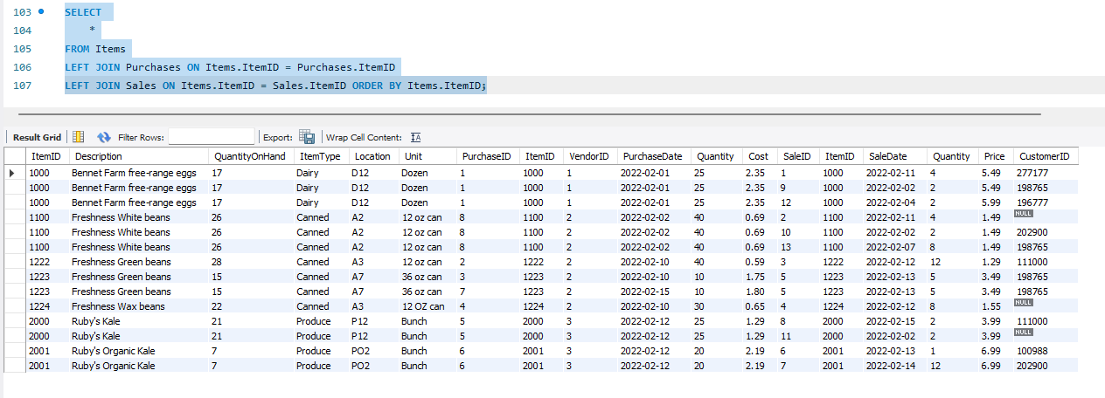

**4. Support for Business Growth:**

The designed database facilitates business growth by:

a. **Scalability:**

* The schema accommodates an expanding product line by providing a scalable structure to add new items, vendors, and transactions.

b. **Efficient Data Retrieval:**

* SQL queries efficiently retrieve data from multiple tables, supporting quick decision-making and business analysis.

c. **Reliable Inventory Management:**

* Accurate quantity on hand calculations contribute to reliable inventory management, supporting increased product diversity.

**5. Future Database Enhancements:**

a. **Enhanced Vendor Information:**

* Consider adding fields to capture additional vendor details (e.g., contact information, contract terms) for comprehensive vendor management.

b. **User Authentication and Authorization:**

* Implement user authentication and authorization mechanisms to ensure secure access to sensitive data, particularly as the business expands.

c. **Data Archiving Strategy:**

* Establish a strategy for archiving historical data to maintain optimal database performance as the volume of transactions grows over time.

In conclusion, the redesigned database addresses initial anomalies, fosters business growth, and lays the groundwork for future enhancements, ensuring a robust and adaptable system for the grocery store.